Established – 1961 Subject: OSDBMS
SEVA SADAN’S


OF
ARTS, SCIENCE & COMMERCE ULHASNAGAR –
421003



CERTIFICATE

This is to certify that Mr./Ms. Sanjana Kheraliya of S.Y. Information
Technology (SYIT) Roll No. 2542017 has satisfactorily completed the Open
Source DataBase Management System Mini Project entitled Bank Customer Account Management System during the academic year 2025 – 2026, as a part of the practical requirement. The project work is found to be satisfactory and is approved for submission.

PROF. INCHARGE HEAD OF DEPT

________________________ __________________________

INDEX

Sr. No. | Chapter Title | PAGE NO
1 | Introduction | 3
2 | Problem Definition | 4
3 | Objectives of the Project | 5
4 | Scope of the Project | 6
5 | Requirement Specification | 8
6 | System Design | 9
7 | Database Design | 10
8 | UML Diagrams | 13
9 | SQL Implementation | 17
10 | System Testing and Result | 20
11 | Security, Backup and Recovery | 24
12 | Future Scope and Conclusion | 25
13 | References | 26
14 | Glossary | 27

CHAPTER 1. INTRODUCTION

The Bank Customer Account Management System is a computerized, database-driven solution designed to store, manage, and analyze customer and banking information efficiently. The main objective of this system is to help bank administrators maintain accurate records of customers, bank branches, accounts, and transactions in a structured and secure database environment

Traditionally, small banking operations or training environments may rely on manual registers or spreadsheets for storing customer and account details. While such methods may work initially, they become inefficient as the number of customers and transactions increases. Manual record-keeping often leads to duplication, calculation errors, missing entries, and difficulty in retrieving historical transaction data

A database-driven system solves these problems by storing information in relational tables. Customer data, branch details, account information, and transaction records are linked using primary and foreign keys. Authorized users can quickly insert, update, delete, and retrieve information using SQL queries. This improves efficiency, accuracy, and decision-making.

CHAPTER 2. PROBLEM DEFINITION
The traditional approach to managing customer accounts, branch details, and banking transactions in many banks, especially smaller or training-focused environments, is often manual or relies on basic spreadsheet software. While these methods may initially seem sufficient, they present significant challenges as the number of customers, accounts, and transactions grows. Manual systems are prone to errors, lack efficiency, and do not scale well for growing banking operations.

One of the major issues in the current system is data redundancy and inconsistency. Customer details may be recorded multiple times across different files or spreadsheets, leading to duplication and conflicting information. For example, a customer's contact information may be updated in one file but remain outdated in another, creating confusion during account management. Similarly, account balances and transaction histories maintained in separate documents may not reflect accurate or synchronized information, leading to potential financial discrepancies.

Another critical problem is the difficulty in tracking transaction history and account balances. In manual systems, retrieving information about deposits, withdrawals, or transfers requires searching through multiple records. This is not only time-consuming but also increases the risk of errors in calculating balances or generating account statements. Tracking branch-wise account activity or analyzing customer trends over time is nearly impossible without a structured database, making decision-making for administrators slow and unreliable.

In summary, the current manual or semi-manual system for bank customer account management suffers from redundancy, inconsistencies, inefficiency in tracking and reporting, lack of data security, and limited scalability. These limitations highlight the urgent need for a structured, database-driven Bank Customer Account Management System. By centralizing all customer, account, and transaction information, reducing redundancy, improving data integrity, and enabling efficient tracking and reporting, the proposed system will significantly enhance operational reliability, improve customer service, and support effective banking management.

CHAPTER 3. OBJECTIVES OF THE PROJECT
The The objective of the Bank Customer Account Management System is to design and implement a database-driven solution that enables efficient storage, management, and analysis of customer accounts, branch information, and transactions. The system is developed to overcome the limitations of manual banking operations by providing accuracy, consistency, and ease of access to data.
This project emphasizes the importance of maintaining resident details, medical records, and payment information in a centralized database. By doing so, administrators and caretakers can easily retrieve and update records without duplication or inconsistency. The system also supports decision-making by generating meaningful reports that highlight medical conditions, payment compliance, and overall resident management.
The main objectives of the project are as follows:
- To design a structured and efficient database
Create a well-organized relational schema to store customer, branch, account, and transaction data, reducing redundancy and maintaining proper relationships.

- To store customer, account, and branch details efficiently
Maintain personal customer details, branch information, account balances, and transaction history in a centralized database for easy tracking and retrieval.

- To implement SQL queries for data manipulation
SQL Use SQL commands to insert, update, delete, and retrieve records accurately. Advanced queries such as JOIN, GROUP BY, and HAVING are used for reporting and analysis
- To ensure data integrity and consistency
Apply constraints like PRIMARY KEY, FOREIGN KEY, NOT NULL, and UNIQUE to prevent duplication and maintain referential integrity across all records .
- To generate performance and management reports
Produce reports that help administrators monitor account activity, transaction histories, branch-wise performance, and customer statistics for informed decision-making.

CHAPTER 4. SCOPE OF THE PROJECT
The scope of the Bank Customer Account Management System defines the boundaries and extent of the project. This system is designed to support bank administrators, branch staff, and management in efficiently handling customer information, account details, branch data, and financial transactions using a structured, database-driven approach. The project focuses on database design and SQL implementation rather than user interface development, ensuring that core operations of data storage, retrieval, and reporting are achieved.
The system provides a centralized database that stores customer details such as name, date of birth, contact information, and address, along with branch information, account details, and transaction history. By maintaining all data in a single database, the system ensures accuracy, consistency, and quick access. Authorized users can insert, update, and retrieve records efficiently, reducing redundancy and improving operational effectiveness.

Users of the System
- Admin/Bank Staff: Responsible for managing customer and account records, creating nw accounts, updating account details, and recording transactions. The admin has full access for data insertion, modification, and report generation
- Branch Managers: Oversee branch-wise customer accounts, monitor transactions, and analyze branch performance.
- Bank Management: Uses the system primarily to access reports and summaries for decision-making, financial planning, and monitoring overall banking operations.

Usage Areas
The The Bank Customer Account Management System can be effectively used in:
- Banks and Financial Institutions: To maintain accurate records of customers, accounts, and transactions.
- Training Institutes and Academic Projects: To demonstrate practical database management in banking scenarios.
- Educational Simulations: To manage virtual banking operations and account activities in a structured manner.

Limitations of the Project
- The project focuses only on database design and SQL queries without developing a graphical user interface.
- No web or mobile interface is included; all operations are performed at the database level.
- Account types, transaction categories, and branch details are predefined and cannot be dynamically modified within the scope of this project.

CHAPTER 5. REQUIREMENT SPECIFICATION
This section describes the hardware and software requirements needed to develop and run the Bank Customer Account Mangement System.

1. Hardware Requirements
The following hardware components are required for the implementation of the system:
- Computer / Laptop – Used for development and execution of the database system
- Minimum 4 GB RAM – Required for smooth operation of MySQL Server and Workbench
- Minimum 20 GB Free Storage – Required for storing customer, account, and transaction data,,backups, and system files

2. Software Requirements
The following software tools are required for the development and execution of the system:
  - Software: Purpose
  - MySQL Server: Database management
  - MySQL Workbench: Query execution and database administration
  - Operating System: Windows / Linux
  - SQL: Query language for database operations
These hardware and software requirements ensure the proper functioning, performance, and reliability of the Bank Customer Account Mangement System.

CHAPTER 6. SYSTEM DESIGN
The system design of the Bank Customer Account Management System defines how the database is structured and how different users interact with it to perform their banking operations. The design focuses on creating a reliable and well-organized database solution that ensures efficient storage, retrieval, and management of customer, account, branch, and transaction data.
The system follows a database-driven architecture, where all operations are performed using SQL queries executed on the MySQL Server. The conceptual workflow can be described as follows:

6.1 System Architecture
- Customer Interaction
Customers’ accounts and transactions are managed indirectly by bank staff. Customer details and account information are stored centrally for retrieval and reporting.
- Admin / Bank Staff Interaction
Administrators interact with the system through SQL queries to insert, update, and retrieve customer, account, branch, and transaction records as required.
- Query Processing by MySQL Server
The MySQL Server processes all queries submitted by users. It performs operations on the database while ensuring accuracy, consistency, and security of all banking data.
- Data Storage in Structured Tables
Customer, account, branch, and transaction information is stored in structured tables. This avoids redundancy and allows efficient retrieval and reporting.
OutputDisplay
Query results are displayed in tabular format, making it easy to read and analyze customer accounts, transaction histories, and branch performance.

CHAPTER 7.DATABASE DESIGN
7.1 Entity Description

Customers
The Customers entity stores personal details of each banking customer. It includes information such as customer ID, first name, last name, date of birth, contact details, email, and address. This entity is central to the system, as accounts and transactions are linked directly to individual customers.

Branches
The Branch entity stores details of each bank branch, including branch ID, branch name, city, and IFSC code. Accounts are associated with branches to track branch-wise customer and account management.

Accounts

The Accounts entity stores account-specific information such as account ID, customer ID, branch ID, account type, balance, opening date, and account status. This entity ensures proper management of all customer accounts.

Transactions
The Transactions entity stores financial activities related to accounts, including transaction ID, account ID, transaction type, amount, and transaction date. This entity ensures all deposits, withdrawals, and other transactions are properly recorded and linked to the respective accounts.

7.2 Table Structure
The database of the Bank Customer Account Management System consists of the following tables:

- Customers Table
This table stores personal details of each banking customer.

Attribute Name | Data Type | Description
account_id | INT | Primary Key, uniquely identifies each account
customer_id | INT | Foreign Key referencing Customers table
branch_id | INT | Foreign Key referencing Branch table
account_type | VARCHAR | Type of account (Savings/Current)
balance | DECIMAL | Current account balance
open_date | DATE | Date when account was opened
status | VARCHAR | Account status (Active/Inactive)

- Transactions Table
This table stores financial transactions linked to accounts.
Attribute Name | Data Type | Description
transaction_id | INT | Primary Key, uniquely identifies each transaction
account_id | INT | Foreign Key referencing Accounts table
transaction_type | VARCHAR | Type of transaction (Deposit/Withdrawal)
amount | DECIMAL | Transaction amount
transaction_date | DATETIME | Date and time of the transaction

- Branch Table
This table stores information about bank branches.
Attribute Name | Data Type | Description
branch_id | INT | Primary Key, uniquely identifies each transaction
branch_name | VARCHAR | Name of the branch
city | VARCHAR | City where the branch is located
ifsc_code | VARCHAR | Unique IFSC code of the branch

- AccountsTable
This table stores Financial information to related residents.
Attribute Name | Data Type | Description
account_id | INT | Primary Key, uniquely identifies each account
customer_id | INT | Foreign Key referencing Customers table
branch_id | INT | Foreign Key referencing Branch table
account_type | VARCHAR | Type of account (Savings/Current)
balance | DECIMAL | Current account balance
open_date | DATE | Date when account was opened
status | VARCHAR | Account status (Active/Inactive)

7.3 Constraints Used
Constraints are used to maintain data integrity and consistency in the database.


• PRIMARY KEY
Ensures that each record in a table is uniquely identified and prevents duplicate entries.


• FOREIGN KEY
Maintains relationships between tables and ensures referential integrity between related records.

• NOT NULL
Ensures that mandatory fields always contain values and cannot be left empty.


• UNIQUE

Prevents duplicate values in specific columns and maintains data uniqueness.

This structured database design ensures accurate data storage, efficient retrieval, and reliable employee performance evaluation.

CHAPTER 8. UML DIAGRAMS

a. ER Diagram

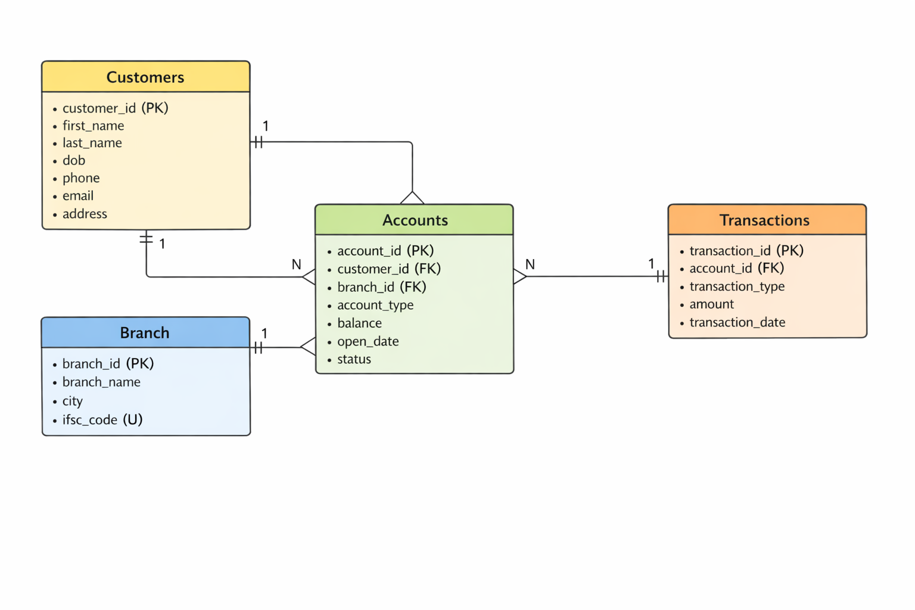
8.1 ER Diagram

b. Activity Diagram

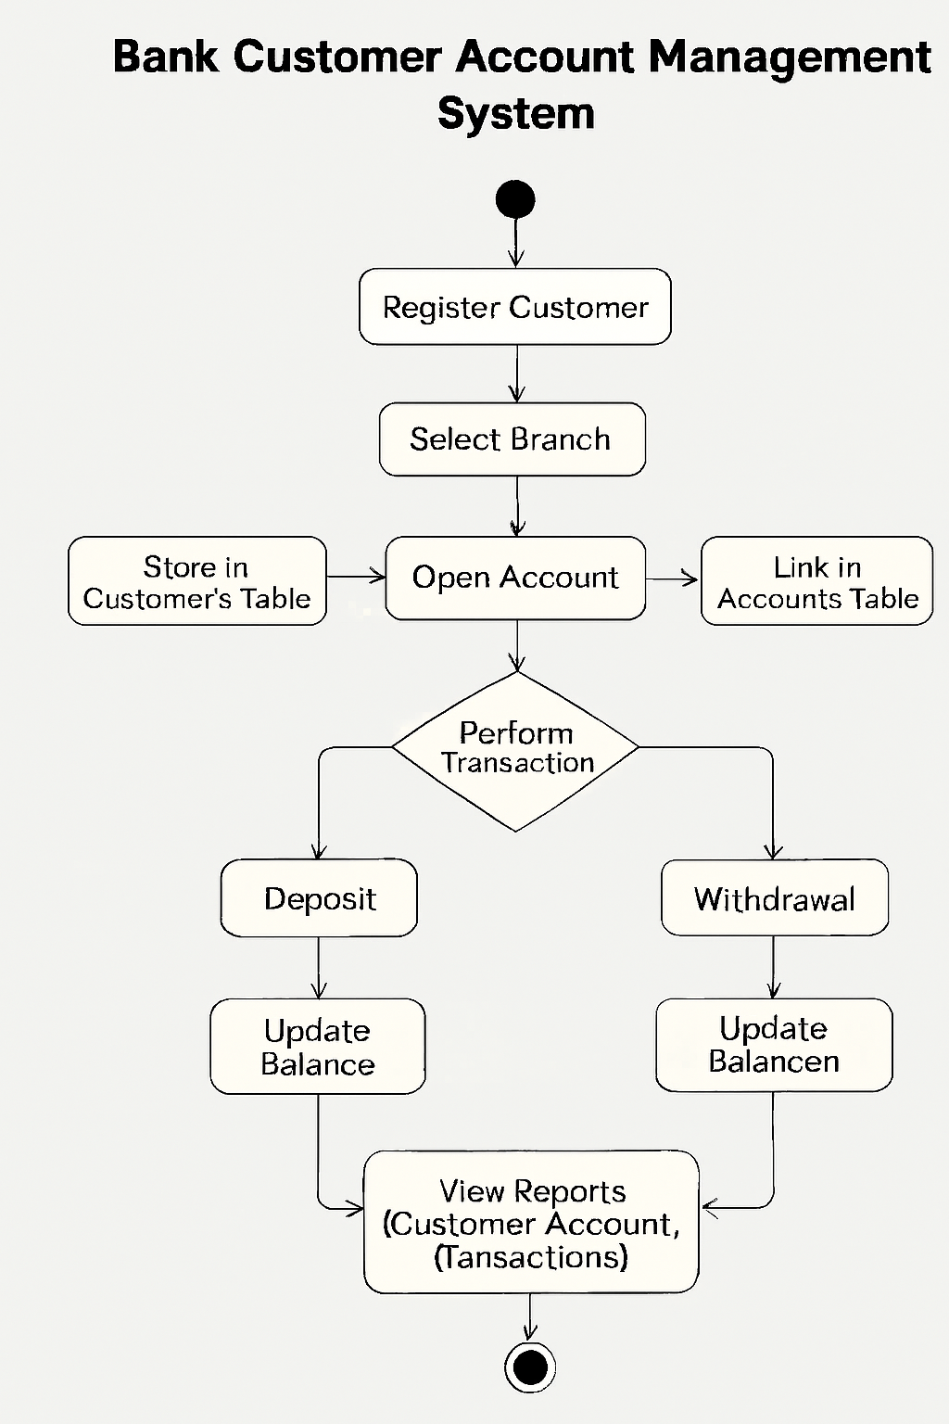
8.2 Activity Diagram

c. Sequence Diagram 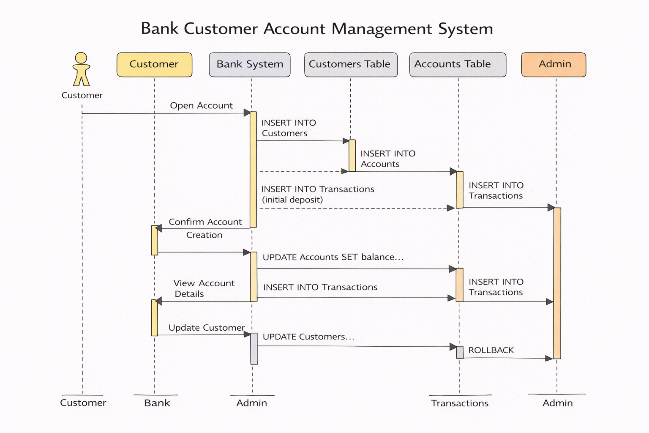

8.3 Sequence Diagram

d.Use Case diagram

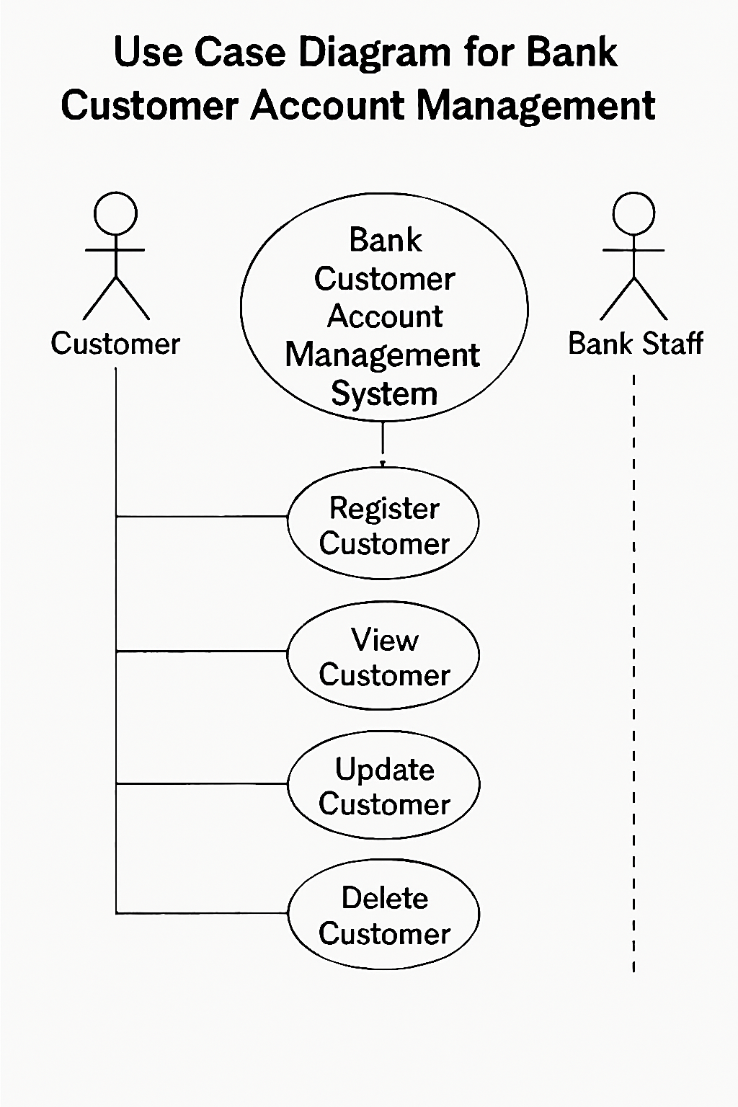
8.4 Use Case Diagram

CHAPTER 9. SQL Implementation
-- 9.1 Database Creation
CREATE DATABASE BankDB;
USE BankDB;
;

-- 9.2 Table Creation
-- Customers Table
CREATE TABLE Customers (
customer_id INT PRIMARY KEY AUTO_INCREMENT,
first_name VARCHAR(50),
last_name VARCHAR(50),
dob DATE,
phone VARCHAR(15),
email VARCHAR(100),
address VARCHAR(100)
);

-- Branch Table
CREATE TABLE Branch (
branch_id INT PRIMARY KEY AUTO_INCREMENT,
branch_name VARCHAR(100),
city VARCHAR(50),
ifsc_code VARCHAR(20) UNIQUE
);

-- Accounts Table
CREATE TABLE Accounts (
account_id INT PRIMARY KEY AUTO_INCREMENT,
customer_id INT,
branch_id INT,
account_type VARCHAR(20),
balance DECIMAL(10,2),
open_date DATE,
status VARCHAR(20),
FOREIGN KEY (customer_id) REFERENCES Customers(customer_id),
FOREIGN KEY (branch_id) REFERENCES Branch(branch_id)
);

-- Transactions Table
CREATE TABLE Transactions (
transaction_id INT PRIMARY KEY AUTO_INCREMENT,
account_id INT,
transaction_type VARCHAR(20),
amount DECIMAL(10,2),
transaction_date DATETIME,
FOREIGN KEY (account_id) REFERENCES Accounts(account_id)
);

-- 9.3 Data Insertion
-- Insert Customers
INSERT INTO Customers(first_name,last_name,dob,phone,email,address) VALUES
('Amit','Sharma','1995-01-02','9811111111','amit@mail.com','Mumbai'),
('Neha','Verma','1996-02-03','9822222222','neha@mail.com','Delhi'),
('Raj','Patel','1994-03-04','9833333333','raj@mail.com','Pune'),
('Sara','Khan','1997-04-05','9844444444','sara@mail.com','Jaipur'),
('Vikram','Singh','1993-05-06','9855555555','vikram@mail.com','Surat');

-- Insert Branches
INSERT INTO Branch(branch_name,city,ifsc_code) VALUES
('Main Branch','Mumbai','BANK0001'),
('City Branch','Delhi','BANK0002'),
('West Branch','Pune','BANK0003'),
('North Branch','Jaipur','BANK0004'),
('Central Branch','Surat','BANK0005');

-- Insert Accounts
INSERT INTO Accounts(customer_id,branch_id,account_type,balance,open_date,status) VALUES
(1,1,'Savings',25000,'2022-01-01','Active'),
(2,2,'Current',30000,'2022-01-02','Active'),
(3,3,'Savings',28000,'2022-01-03','Active'),
(4,4,'Current',35000,'2022-01-04','Active'),
(5,5,'Savings',40000,'2022-01-05','Active');

-- Insert Transactions
INSERT INTO Transactions(account_id,transaction_type,amount,transaction_date) VALUES
(1,'Deposit',5000,NOW()),
(2,'Withdrawal',2000,NOW()),
(3,'Deposit',3000,NOW()),
(4,'Withdrawal',1500,NOW()),
(5,'Deposit',7000,NOW());

--9.4 Simple Queries

--WHERE
SELECT * FROM Customers WHERE customer_id=1;

-- SELECT: Retrieve selected columns from Customers table
SELECT customer_id, first_name, last_name, address
FROM Customers;
-- UPDATE: Modify the first and last name of a specific customer
UPDATE Customers
SET first_name='Rohit',
last_name='Mehta'
WHERE customer_id=1;
-- DELETE: Remove a specific transaction record
DELETE FROM Transactions
WHERE transaction_id = 9999;

--9.6 Advanced Queries
-- Transactions with rollback example
START TRANSACTION;
UPDATE Accounts
SET balance = balance-1000
WHERE account_id=2;
ROLLBACK; -- Undo the transaction
SELECT * FROM Accounts WHERE account_id=2;

-- Multiple updates in a transaction(Concurrency)
START TRANSACTION;
UPDATE Accounts
SET balance = balance - 1000
WHERE account_id=1;
START TRANSACTION;
UPDATE Accounts
SET balance = balance - 500
WHERE account_id = 1;
SELECT * FROM Accounts WHERE account_id=1;
COMMIT;

CHAPTER 10. SYSTEM TESTING AND RESULT

System testing was performed to ensure that the Bank Customer Account Management System functions correctly and produces accurate results. All database operations were tested using MySQL Workbench to verify correctness, reliability, and data integrity.

10.1 Database Verification
Query:


Output verifying that all tables (Customers, Branch, Accounts, Transactions) are created successfully in BankDB.

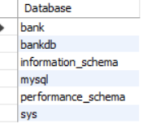

10.2 Table Data Verification
Query:
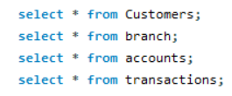
Customers TABLE:

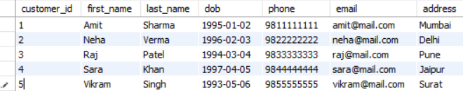

Branch TABLE:

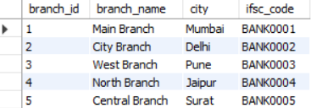

Accounts TABLE:
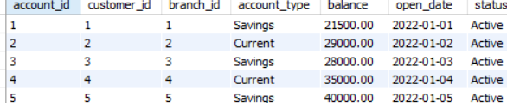

Transactions TABLE:
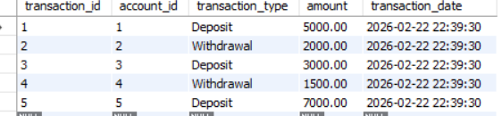
Verifies that all tables contain the inserted data.

10.3 Simple Queries
WHERE Clause:
The output verifies that the WHERE condition worked successfully.

SELECT Specific Columns:

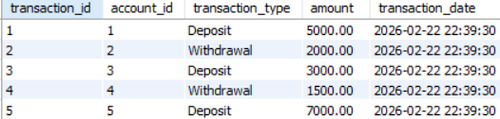
The output verifies that selecting specific columns worked successfully.

10.4 Data Update
UPDATE Query:
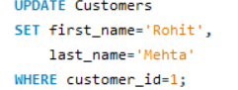
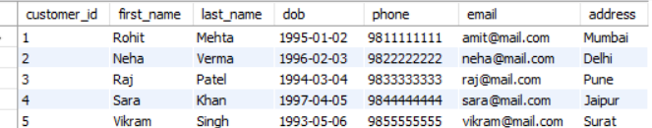
The output verifies that the UPDATE query executed successfully.

10.5 Delete Query
DELETE Query:
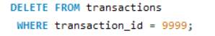
The output verifies that the DELETE query executed successfully.

10.6Transaction Queries
ROLLBACK Example:

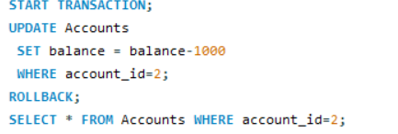
The output verifies that ROLLBACK successfully reverted changes.

Overlapping Transactions Example:
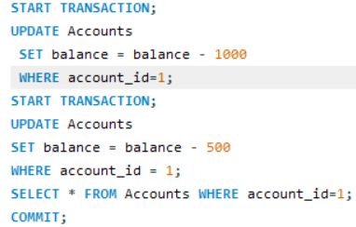
The output verifies that multiple concurrent transactions on the same account are serialized correctly, and COMMIT ensures the final balance reflects all intended updates. This demonstrates concurrency in action.

CHAPTER 11. SECURITY, BACKUP AND RECOVERY

- Security
  - User Authentication: Only authorized users can access the system.
  - Data Integrity: Database constraints (Primary Key, Foreign Key, NOT NULL, CHECK) ensure that only valid data is stored.
  - Access Control: Sensitive information such as customer accounts, balances, and transactions is restricted to authorized personnel.
  - SQL Injection Prevention: Queries are executed with proper validation to avoid malicious inputs.

- Backup
• Regular Backups: The BankDB database is periodically backed up to prevent loss of customer and transaction data.
• Backup Storage: Backups are stored securely in a separate location from the main database.
• Incremental Backup: Only changes since the last backup are stored, saving time and storage.
• Emergency Backup: Full backups are taken before major updates or maintenance.

- Recovery
- Point-in-Time Recovery: In case of accidental deletion or corruption, the database can be restored to a specific timestamp.
- Rollback Mechanism: Transaction management ensures that failed or incomplete operations (like money transfers) are rolled back automatically.
- Disaster Recovery: Backup files can be used to restore the database quickly in case of hardware failure or system crash.
- Testing Recovery: Recovery procedures are periodically tested to verify reliability.
Conclusion:
The Bank Customer Account Management System ensures customer and transaction data is secure, consistent, and available even in case of failures.

CHAPTER 12. FUTURE SCOPE AND CONCLUSION

Future Scope

The Bank Customer Account Management System can be further improved by adding new features and technologies in the future:

Web-based Banking Interface:
The system can be converted into a web application so that bank staff or customers can access it through a browser. This will allow remote access and make banking operations more user-friendly.

Automated Transaction Alerts:
Automatic notifications can be sent to customers for deposits, withdrawals, low balances, or suspicious transactions, improving account monitoring.

Graphical Reports:
Reports such as bar charts, pie charts, and trend graphs can be generated to visually represent account balances, transactions, and branch performance. This will support better decision-making.

Integration with ATM/Banking APIs:
The system can be integrated with ATM machines, mobile banking apps, or other banking APIs, allowing real-time updates of account balances and transactions.

Mobile Application:
A mobile app can be developed to provide customers with quick access to account information, transaction history, and notifications anytime, anywhere.

Conclusion

The Bank Customer Account Management System successfully demonstrates the use of MySQL for managing customer, account, and transaction data in a structured and efficient manner. The project helped in understanding important database concepts such as table design, relationships, SQL queries, transactions, and data integrity constraints.

This system provides a practical and reliable solution for storing, retrieving, and analyzing banking data. Overall, the project highlights the importance of database management systems in financial institutions and forms a strong foundation for developing advanced banking management applications in the future.

CHAPTER 13. REFERENCES
- MySQL Official Documentation:
MySQL Documentation, Oracle Corporation. Used as the primary reference for understanding MySQL commands, database creation, table design, queries, security, backup, and recovery concepts.
- Prescribed Textbooks:
Standard textbooks on Database Management Systems recommended in the academic syllabus. These books were referred to for understanding basic DBMS concepts such as relational databases, SQL queries, constraints, and normalization.
- Online Learning Sources:
Educational websites, tutorials, and online learning platforms related to SQL and MySQL. These sources helped in learning practical query execution,
examples, and best practices for database implementation.For diagrams draw.io,lucidchart.

CHAPTER 14.GLOSSARY
The glossary section provides simple meanings of important terms used throughout the Office Asset Management project. These terms are related to database systems and SQL concepts that are essential to understand how the project works. The definitions are written in easy language so that readers with basic or no prior knowledge of databases can understand them clearly. This section helps remove confusion and acts as a quick reference for technical words used in the documentation.
DBMS (Database Management System):
A DBMS is software that is used to store, manage, and retrieve data in an organized way. It allows users to handle large amounts of data efficiently and securely.

SQL (Structured Query Language):
SQL is a standard language used to communicate with a database. It is used to create tables, insert data, retrieve records, and manage database operations.
Primary Key:
A primary key is a field that uniquely identifies each record in a table. It ensures that no two records have the same value.

Foreign Key:
A foreign key is a field that connects one table to another table. It helps maintain relationships and data consistency between tables.

MySQL:
MySQL is an open-source relational database management system used to create and manage databases. It is widely used because it is reliable, easy to use, and supports all basic database features.

